**Department of Engineering Technology**

**Foundation University School of Science and Technology**

**Lab Report**

**Introduction to Web Technologies Lab**

**Name:** Ramesha Irfan

**Roll no:** Fall-23-035

# Lab 10: PHP Based Data Insertion

**OBJECTIVES:**

1. Objective 1
2. Objective 2

|  |  |  |  |  |  |
| --- | --- | --- | --- | --- | --- |
| **Performance** | |  | **Lab Report** | |  |
| **Description** | **Total**  **Marks** | **Marks Obtained** | **Description** | **Total**  **Marks** | **Marks Obtained** |
| Code Writing | 5 |  | Communication | 5 |  |
| **Total Marks Obtained** | | |  | |  |

**Remarks (if any): ………………………………….......................**

**Name & Signature of faculty: …………………………………...**

**Task/Assignment:**

1. Create a MySQL DB in phpMyAdmin for your Semester Project/BDP
2. Insert data in the DB from all the input forms (at least 3) of your BDP
3. Test Data is stored in MySQL DB using phpMyAdmin

## ● Create Tables in the Database

CREATE TABLE students ( id INT AUTO_INCREMENT PRIMARY KEY,

full_name VARCHAR(100),

email VARCHAR(100),

age INT,

department VARCHAR(50)

);

CREATE TABLE course_enrollments (

id INT AUTO_INCREMENT PRIMARY KEY,

student_id INT, course_name VARCHAR(100), semester VARCHAR(10),

FOREIGN KEY (student_id) REFERENCES students(id)

);

CREATE TABLE feedback ( id INT AUTO_INCREMENT PRIMARY KEY,

student_id INT, comments TEXT,

rating INT,

FOREIGN KEY (student_id) REFERENCES students(id)

);

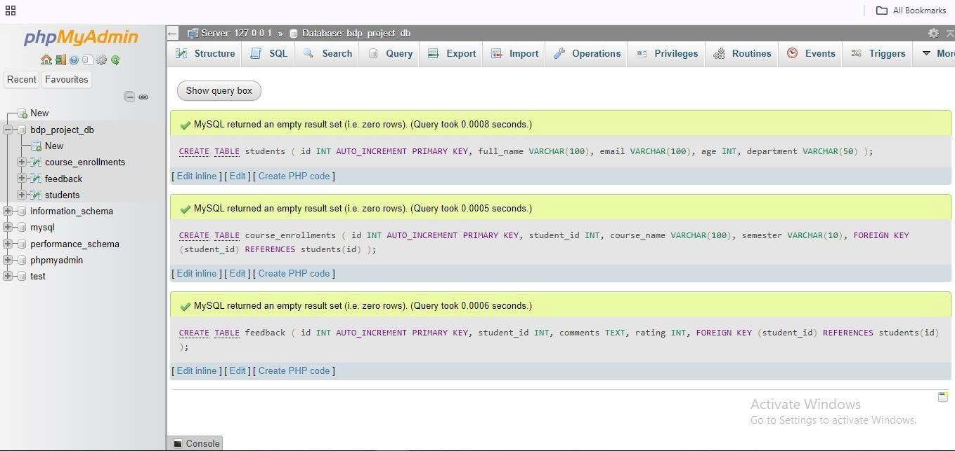

## ● Create PHP Project in VS Code

### 1. student_form.php

<!DOCTYPE html>

<html>

<head><title>Student Registration</title></head>

<body>

<h2>Student Registration Form</h2>

<form method="POST" action="insert_student.php">

Full Name: <input type="text" name="full_name"><br><br>

Email: <input type="email" name="email"><br><br>

Age: <input type="number" name="age"><br><br>

Department: <input type="text" name="department"><br><br>

<input type="submit" value="Register">

</form>

</body>

</html>

### 2. insert_student.php

<?php

$conn = new mysqli("localhost", "root", "", "bdp_project_db");

if ($conn->connect_error) {

die("Connection failed: " . $conn->connect_error);

}

$name = $_POST['full_name'];

$email = $_POST['email'];

$age = $_POST['age'];

$dept = $_POST['department'];

$sql = "INSERT INTO students (full_name, email, age, department)

VALUES ('$name', '$email', $age, '$dept')";

if ($conn->query($sql) === TRUE) { echo "Student registered successfully.";

} else {

echo "Error: " . $conn->error;

}

$conn->close();

?>

### 3. course_form.php

<!DOCTYPE html>

<html>

<head><title>Course Enrollment</title></head>

<body>

<h2>Course Enrollment Form</h2>

<form method="POST" action="insert_course.php">

Student ID: <input type="number" name="student_id"><br><br>

Course Name: <input type="text" name="course_name"><br><br>

Semester: <input type="text" name="semester"><br><br>

<input type="submit" value="Enroll">

</form>

</body>

</html>

### 4. insert_course.php

<?php

$conn = new mysqli("localhost", "root", "", "bdp_project_db");

if ($conn->connect_error) {

die("Connection failed: " . $conn->connect_error);

}

$student_id = $_POST['student_id'];

$course = $_POST['course_name'];

$semester = $_POST['semester'];

$sql = "INSERT INTO course_enrollments (student_id, course_name, semester) VALUES ($student_id, '$course', '$semester')";

if ($conn->query($sql) === TRUE) { echo "Course enrolled successfully.";

} else {

echo "Error: " . $conn->error;

}

$conn->close();

?>

### 5. feedback_form.php

<!DOCTYPE html>

<html>

<head><title>Feedback Form</title></head>

<body>

<h2>Feedback Form</h2>

<form method="POST" action="insert_feedback.php">

Student ID: <input type="number" name="student_id"><br><br>

Comments: <textarea name="comments"></textarea><br><br>

Rating (1-5): <input type="number" name="rating" min="1" max="5"><br><br> <input type="submit" value="Submit Feedback">

</form>

</body>

</html>

### 6. insert_feedback.php

<?php

$conn = new mysqli("localhost", "root", "", "bdp_project_db");

if ($conn->connect_error) {

die("Connection failed: " . $conn->connect_error);

}

$student_id = $_POST['student_id'];

$comments = $_POST['comments'];

$rating = $_POST['rating'];

$sql = "INSERT INTO feedback (student_id, comments, rating)

VALUES ($student_id, '$comments', $rating)";

if ($conn->query($sql) === TRUE) { echo "Feedback submitted successfully.";

} else {

echo "Error: " . $conn->error;

}

$conn->close();

?>

## ● Run and Test the Forms

<http://localhost/bdp_project/student_form.php> <http://localhost/bdp_project/course_form.php>

<http://localhost/bdp_project/feedback_form.php>